International Banking Crises (4/16/2012) Econ 390-001

Definitions
- exchange rate crisis – (aka balance of payments crisis) big depreciation in the currency; drain of foreign reserves forcing a devaluation or switch to float
- banking crisis – bank panics leading to massive bank failures; when banks and other institutions face losses, insolvency, and bankruptcy
- default crisis – government default on sovereign debt; when governments are unwilling or unable to honor principal/interest payments on their debt
- twin crisis – 2/3 of exchange rate, banking, and default crises
- triple crisis – 3/3 of exchange rate, banking, and default crises
- currency premium – exchange rate risk premium; higher interest rate that must be paid to compensate for possibility of fluctuations in the exchange rate (i.e., the peg is not credible)
- country premium – default risk premium; higher interest rate that must be paid to compensate for possibility of government expropriation of private investment or default on sovereign debt
- sovereign default – repudiation of debt; country government default on its bonds
- partial repudiation – declaration by government that it won’t pay back part of its debt (or will pay pennies on the dollar)

Equations
- Y – (1 + r_{L})L > Y – cY sovereign default equation (repay if true; default if false)

Variables
- Y ≡ nominal output
- L ≡ amount of loan (bonds)
- r_{L} ≡ loan rate of interest
- c ≡ % of output lost in default

Principles
- Often these crises occur together (twin or triple crises).
- In general countries that default on their sovereign debt get hit with a 4-5% country risk premium for the next 3-10 years.
- Argentina suffered a triple crisis (2001-2002): exchange rate, banking, and default.

Types of international crises
- exchange rate crisis
- banking crisis
- default crisis

Costs of defaulting
- financial market penalties
  - can’t borrow until resolved
  - downgrade in credit ratings
    - higher country risk premium
  - can’t borrow in own currency
- broader macroeconomic costs
  - bank panics
    - financial disintermediation
  - lost investment, trade, output

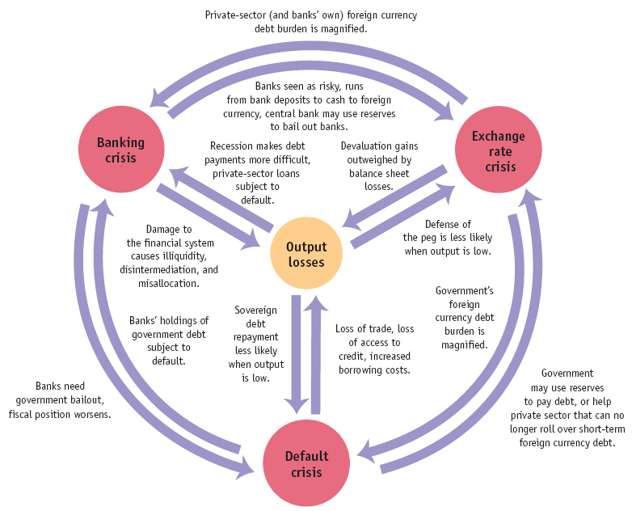
Argentina (2001-2002)
- fixed exchange rate
  - 1:1 peg (peso to dollar)
- current account deficit
  - imports > exports
  - ↓ foreign exchange reserves
- future devaluation feared
  - bank runs began
    - convert pesos to dollars
    - withdraw money
- government devalues peso
  - 1.4:1 new peg (pesos to dollars)
  - force converts bank accounts
    - dollar accounts to pesos
    - 30% of wealth seized
- devaluation ramifications
  - more bank panics
  - foreign investors avoid bonds
    - don’t roll over debt
  - macroeconomic consequences
    - tax revenue declines
    - social welfare spending up
  - government debt unsustainable
- government repudiates debt
  - only default on foreign held debt
    - arbitrage opportunity
    - people buy foreign held debt at discount
    - so default on all debt
  - partial repudiation
    - pennies on dollar for most
    - IMF paid in full
- effects
  - triple crisis
    - exchange rate
    - banking
    - default
  - unemployment hit 25%
  - inflation peaked at 10%/month
  - all bank accounts frozen for 1 year
  - massive exchange rate devaluation
    - from 1:1 to 4:1
(pesos to dollars)

