Trade Policy Controversies (2/29/2012) Econ 390-001

Definitions
- externality – benefits or costs that accrue to parties other than the one that generates it
- strategic trade policy – government policy to give a domestic firm a strategic advantage in production
- beggar-thy-neighbor policy – increase own welfare at another country’s expense
- pollution haven – an economic activity subject to strict environmental controls in some countries is moved to other countries with less strict regulation

Principles
- An activist trade policy usually means export subsidies or general subsidies to exporting industries.
- Activist trade policies are justified using a market failure argument
  - externalities
    - positive
      - appropriability problem
      - e.g., technology
    - negative
      - environmental damage
  - monopoly profits
- Firms that invest in new technology create knowledge that other firms can use without paying for it.
  - This is an appropriability problem: an externality in which marginal social benefit of investment is not represented by producer surplus.
  - Governments may want to actively encourage investment in technology when externalities in new technologies create a high marginal social benefit.
- Problems with intervention
  - Can (or will) governments to subsidize the right activity?
    - Much activity by high tech firms does not generate knowledge.
      - e.g., equipment purchases, salary for non-tech workers
  - Knowledge & innovation can be created in non- high tech industries.
  - It’s difficult to measure the marginal social benefit of externalities.
    - So it’s hard to know by what amount activities ought to be subsidized.
  - Externalities can also occur across countries.
    - No individual country would have an incentive to subsidize industries if all countries could take advantage of the externalities.
- The case for government subsidizing technology is quite dubious given those problems.
- The U.S. subsidizes R&D through the tax code instead of subsidizing specific industries.
  - Research and development expenses are tax deductible.
- In contrast, Japan deliberately promoted key industries.
  - 1980s: fear Japan’s dominance of RAM market would lead to dominance of all semiconductors.
  - But Japan did not takeover all semiconductors & South Korea challenged its RAM dominance.
- The decline in U.S. employment in the production of information, communication, and technology goods and large U.S. trade deficits in those goods have renewed fears about U.S. high tech industries.
  - But innovation in the U.S. + manufacturing in low cost countries isn’t really a problem.
- More generally, decline in manufacturing employment is not a bad thing.
  - Although manufacturing employment is down, manufacturing output continues to rise.
    - Technology makes each worker more productive (machines replace workers).
  - Additionally, there is nothing inherently better about manufacturing jobs.
    - As manufacturing jobs decline, service jobs rise.
    - Service jobs tend to involve more education, less physical labor, and higher salaries.
- Imperfectly competitive industries are typically dominated by a few firms with monopoly profits.
  - But government subsidies can shift monopoly profits from a foreign firm to a domestic firm.
- Brander-Spencer analysis (strategic trade policy with game theory)
  - Setup
    - Two firms compete in the international market but are located in different countries.
    - Each firm’s profits depends on the actions of the other.
    - Each firm decides to produce or not depending on profits.
  - Insights
    - The predicted outcome depends on which firms invest/produce first.
    - If Boeing produces first, then Airbus won’t produce.
    - If Airbus produces first, then Boeing won’t produce.
  - Twist: strategic trade policy in the form of a subsidy
    - A subsidy(+25) by the European Union can alter the outcome.
      - Makes it profitable for Airbus to produce regardless of Boeing’s action.
      - Boeing will then be deterred from entering the industry.
    - The EU subsidy of 25 gives Airbus profits of 125.
      - Here the subsidy raises profits more than the amount of the subsidy.
      - This is due to its deterrent effect on foreign competition.
- Criticisms of strategic trade policy
  - requires too much information about firms
  - foreign governments could retaliate
  - manipulable by politically powerful groups
- Compared to rich-country standards, environmental standards in developing countries are very lax.
  - Some oppose free trade because of increased production increases in these countries.
- Environmental activists want environmental standards to be part of trade negotiations.
  - But developing countries oppose such standards.
  - Standards can be used as an excuse for protectionism.
  - Resentment: developed countries such as the United States had lax environmental standards during their growth, but now want to make growth harder for developing countries.
- Environmental Kuznets curve
  - As poor countries grow richer they produce more and can consume more.
    - Increasing environmental damage (left side of curve).
  - But as countries grow richer, they want to pay for more environmental protection.
    - Reducing environmental damage (right side of curve).
  - The environmental Kuznets curve shows being green is a normal good.
    - People demand more of it as income goes up.
    - Best way to improve environment long term is to increase real incomes until all are rich.
- Pollution havens
  - Evidence shows the pollution haven effect on international trade is relatively small.
    - Production that seems to move for pollution havens more often attracted to low wages.
  - To the extent that pollution is limited to a country, it isn’t other countries’ problem.
    - When it causes a negative externality for others, include it in trade negotiations.
    - Air pollution in Mexico City is a problem for Mexico, not the United States.
  - A better case can be made that global warming affects all countries.
    - Unilaterally limiting carbon emissions from the U.S. would have little effect because production would shift to other countries (like China) in a pollution haven effect.
    - Only taxes or tariffs applied to the whole world could effectively curb it.
    - Cure may be worse than disease: lower growth rates (e.g., right side of Kuznets).

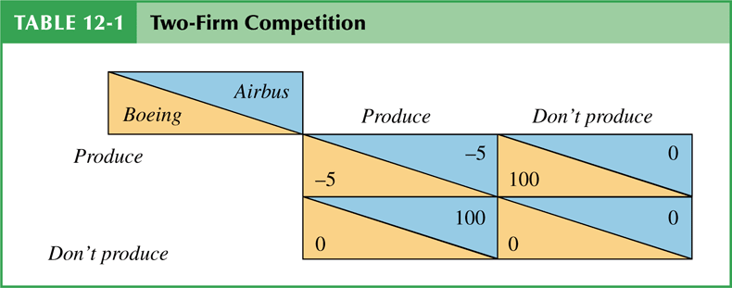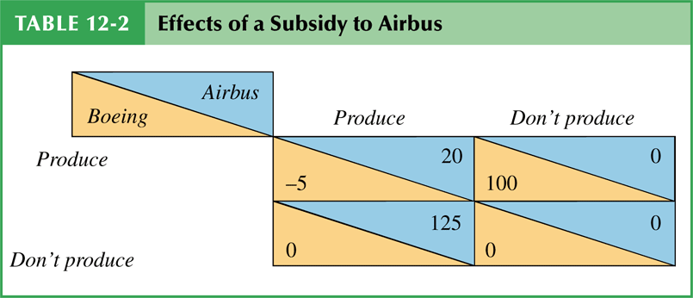

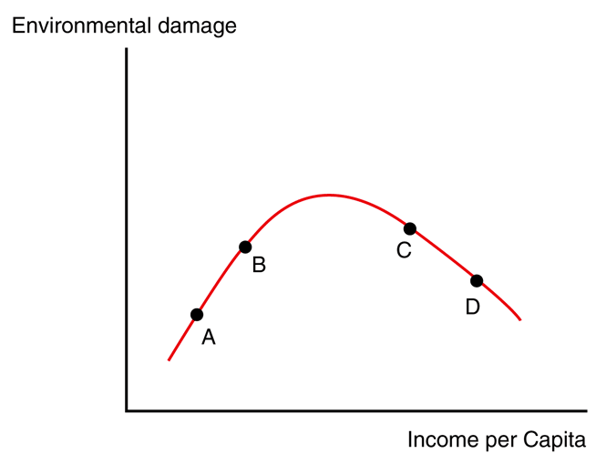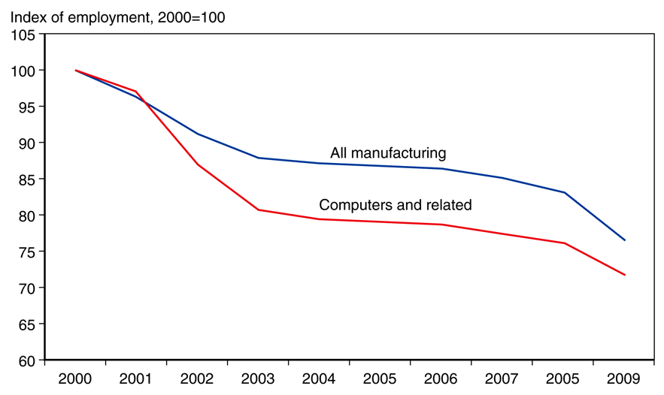
Environmental Kuznets curve manufacturing jobs in the U.S. by year

