External Economies of Scale (2/8/2012) Econ 390-001

Equations
- returns to scale
  - F(aK,aL) = aF(K,L) constant returns to scale
  - F(aK,aL) > aF(K,L) increasing returns to scale

Definitions
- constant returns to scale – increases in output are proportional to increases in inputs
- increasing returns to scale – increases in output are more than proportional to increases in inputs
  - a.k.a. economies of scale
- external economies of scale – cost per unit of output depends on the size of the industry
- internal economies of scale – cost per unit of output depends on the size of a firm
- specialized suppliers – a single firm would not be a large enough market to support specialized equipment or support services, but an entire industry concentrated in one location is large enough
- labor pooling – a large and concentrated industry may attract a pool of workers, reducing employee search and hiring costs for each firm
- knowledge spillovers – workers from different firms may more easily share ideas that benefit each firm when a large and concentrated industry exists
- forward-falling supply curve – average cost of production falls as industry output rises
  - a.k.a. downward sloping supply curve
- dynamic increasing returns to scale – average costs fall as cumulative output over time rises
  - a.k.a. dynamic economies of scale
  - c.f.: increasing returns to scale – average costs fall as current output rises
- infant industry argument – temporary protection of industries allows them to gain experience and thus economies of scale
- economic geography – the study of international trade, interregional trade and the organization of economic activity in metropolitan and rural areas
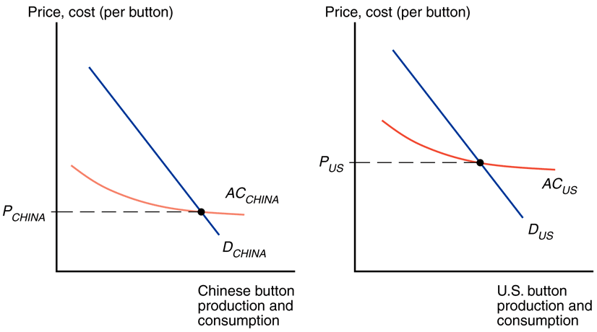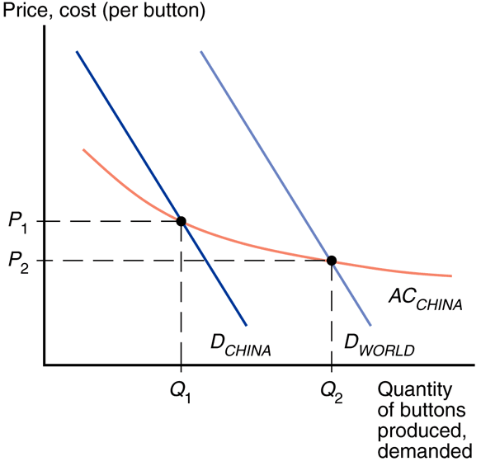
external economies of scale (before trade) external EoS (after trade)
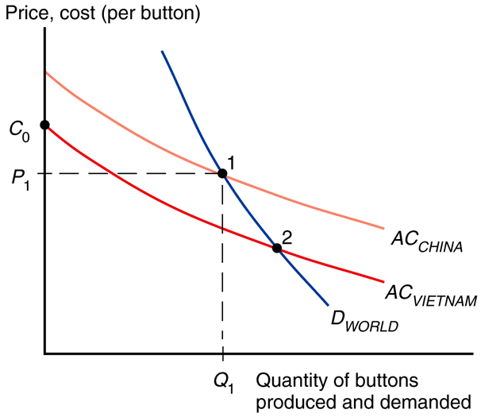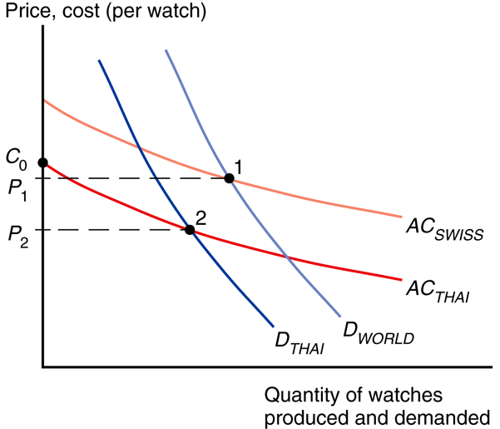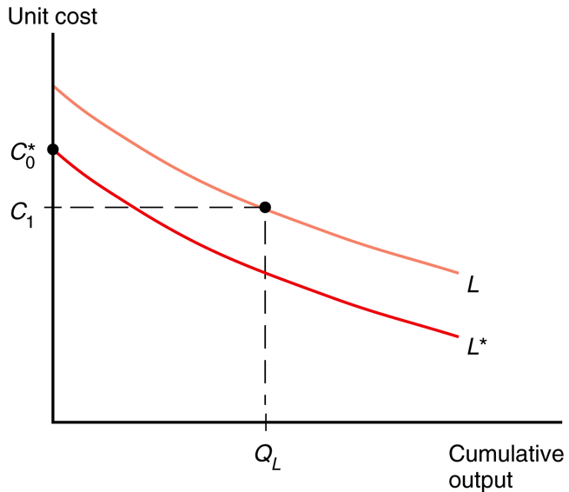
head start country blocks lower cost Thailand better in autarky learning curve
Principles
- Returns to scale of models studied:
  - Constant returns to scale
    - Ricardian model
    - specific factors model
    - Heckscher-Ohlin model
    - standard trade model
  - Increasing returns to scale
    - External economies of scale model
      - this lecture (Krugman Ch. 7)
    - Internal economies of scale model
      - next lecture (Krugman Ch. 8)
- Increasing returns to scale:
  - Doubling inputs more than doubles output.
  - Average cost falls as output rises (more efficient).
- Mutually beneficial trade can arise as a result of economies of scale.
  - Each country can produce a limited range of goods (taking advantage of economies of scale to produce more efficiently) without sacrificing variety in consumption.
- Economies of scale:
  - External economies of scale
    - Cost per unit of output depends on the size of the industry.
    - Typically consists of many perfectly competitive small firms.
  - Internal economies of scale
    - Cost per unit of output depends on the size of a firm.
    - Typically consists of imperfectly competitive large firms.
- External economies of scale examples
  - Silicon Valley, CA, USA
    - semiconductors
  - Hollywood, CA, USA
    - entertainment
  - New York City, NY, USA
    - investment banking
  - Qiaotou, China
    - buttons
- Reasons for external economies of scale
  - specialized suppliers
  - labor market pooling
  - knowledge spillovers
- External economies of scale can be represented by a declining AC curve (downward sloping supply).
- International trade
  - Before international trade equilibrium prices and output for each country are at the intersection of domestic supply and domestic demand.
  - After trade industry expands in the lower cost county and contracts in the higher cost country.
    - As the industry expands in the lower cost country, its costs fall and its prices fall.
    - As the industry contracts in the higher cost country, its costs rise and its prices rise.
  - The lower cost country gets all the industry production.
  - Trade leads to prices that are lower than either country’s autarky prices.
    - In the standard trade model (with constant returns to scale) relative prices converge: the effect of trade is to raise prices in the relatively cheap country and reduce them in the relatively expensive country.
    - With external economies (increasing returns to scale) trade reduces prices everywhere.
- What causes initial price advantages?
  - comparative advantage
    - differences in technology & resources
  - historical accidents
    - start as large producers
- Determining the country of industry concentration
  - The country with the lowest potential AC curve may not get the industry.
  - Another country may get a head start by historical accident.
  - When the country with the lower AC curve considers entering the market, the cost for its initial production will be far above the world price. Therefore it will not enter even though if it produced all the industry for the world its price would be cheaper than the current world price.
- Welfare considerations
  - There will be gains to the world economy by concentrating industries with external economies.
  - But with external economies of scale it is theoretically possible for a country to be better of in autarky than with trade.
    - A country with a lower AC curve that is blocked from profitably producing by a country that got a head start (establishing a low world price) could produce cheaper in autarky given an opportunity to achieve economies of scale.
    - In practice it is very hard to ex ante identify industries that would have a lower cost than the world’s if trade were blocked.
- Dynamic increasing returns to scale
  - Dynamic increasing returns to scale can arise if production cost depends on the accumulation of knowledge and experience.
  - The learning curve is a graphical representation of dynamic increasing returns to scale.
  - Like external economies of scale, dynamic increasing returns to scale can lock in an initial advantage in an industry.
    - This can be used to justify protectionism through the infant industry argument.
    - “Temporary” protection often persists for many, many years.
    - It is hard to identify ex ante when (dynamic) external economies of scale really exist.
- Economic geography
  - External economies may be important for interregional trade within a country.
    - entertainment in Hollywood, CA
    - financial firms in New York City, NY
  - Some nontradable goods like newspapers and haircuts must be supplied locally.
  - If external economies exist, the pattern of trade may be due to historical accidents.

