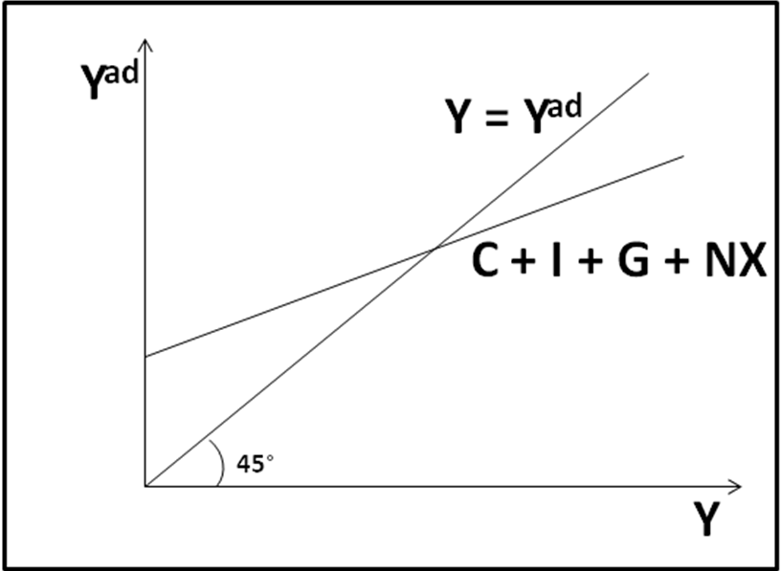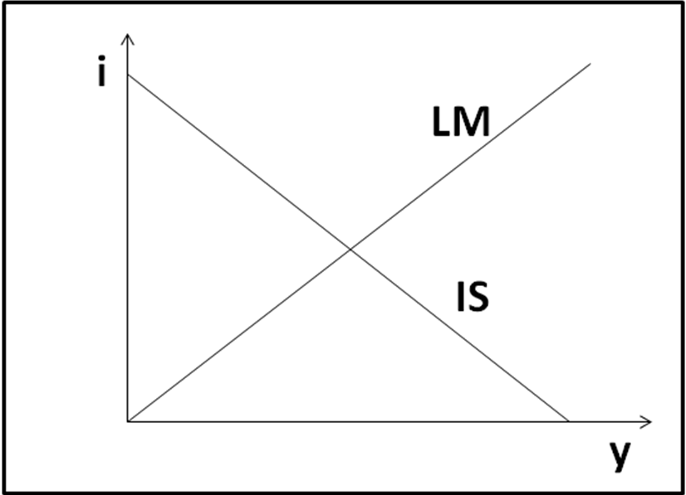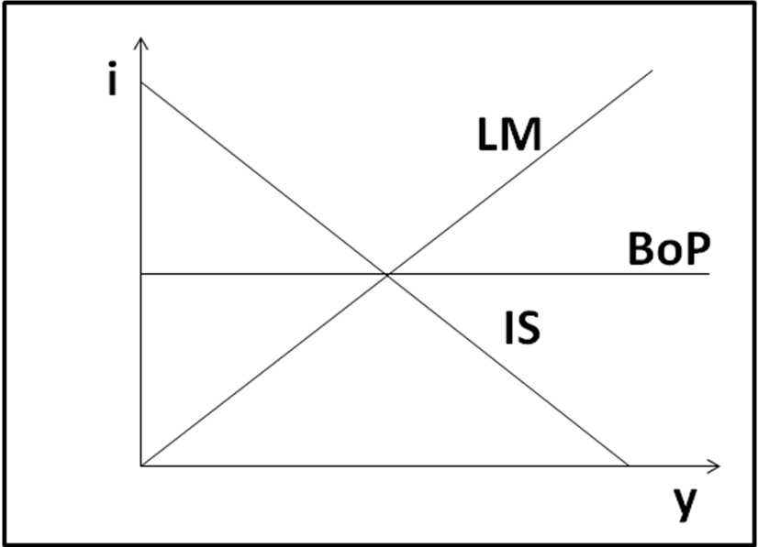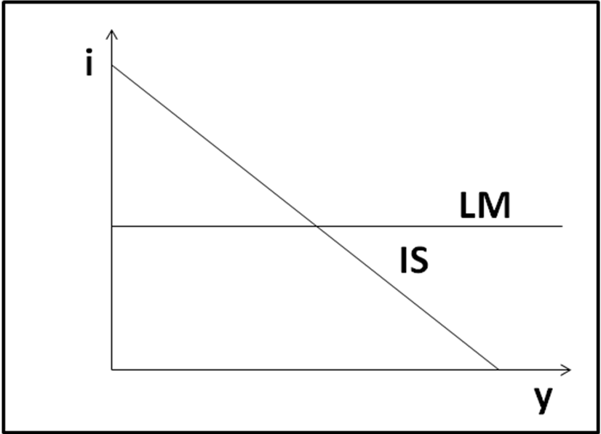
Keynesian Cross IS/LM model Mundell-Fleming IS/LM: liquidity trap

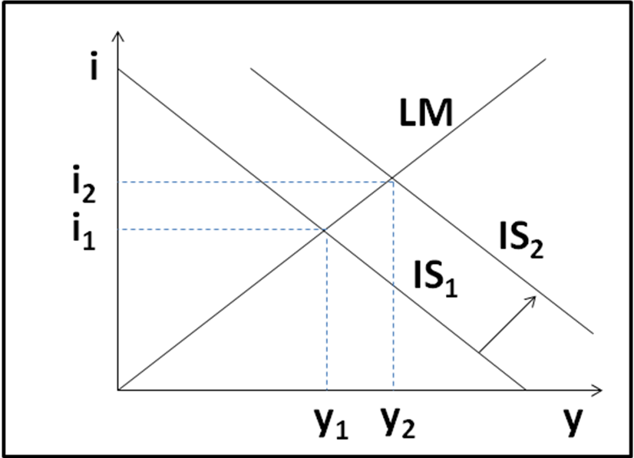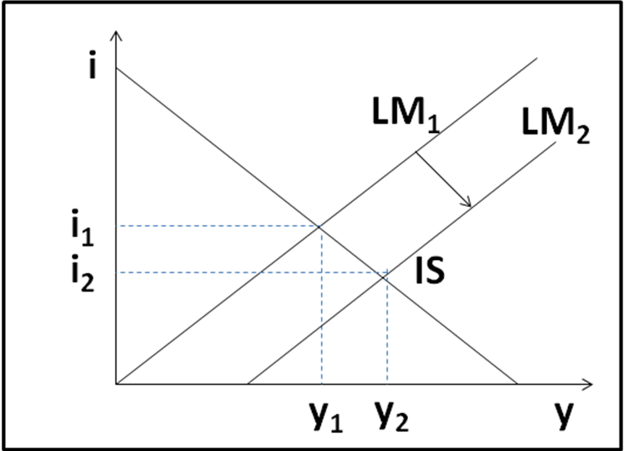
 | float | fixed
FP | 0 | +
MP | + | 0
 | float | fixed
FP | + | 0
MP | + | 0
IS/LM: IS shift right (e.g., G↑) IS/LM: LM shift right (e.g., M^{S}↑) MF: Perfect capital mobility MF: No capital mobility

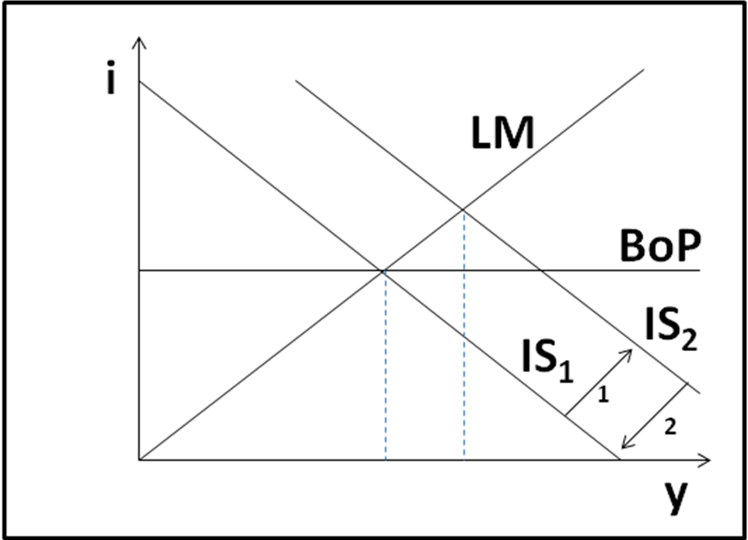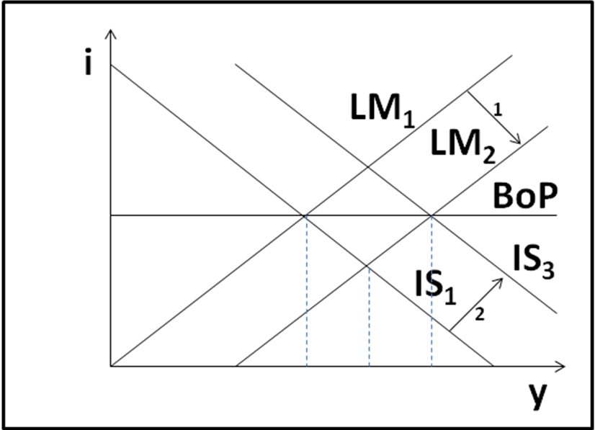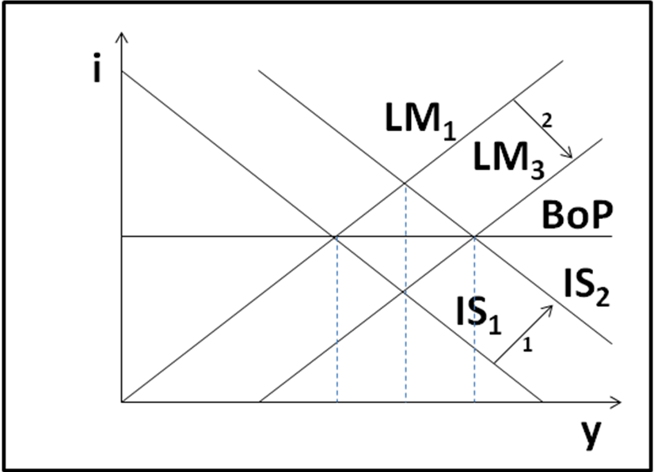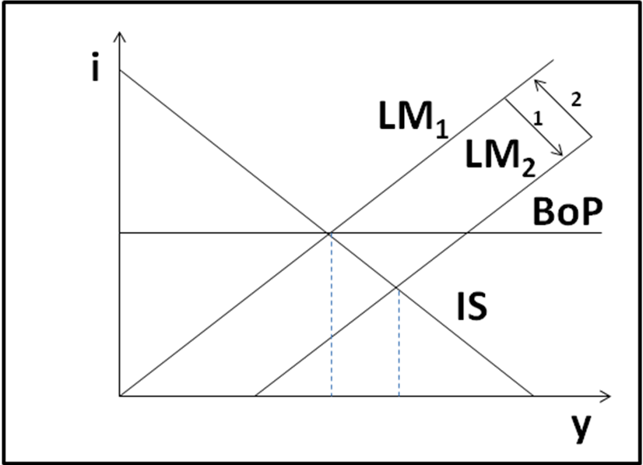
MF: perfect CM, float, fiscal MF: perfect CM, float, monetary MF: perfect CM, fixed, fiscal MF: perfect CM, fixed, monetary

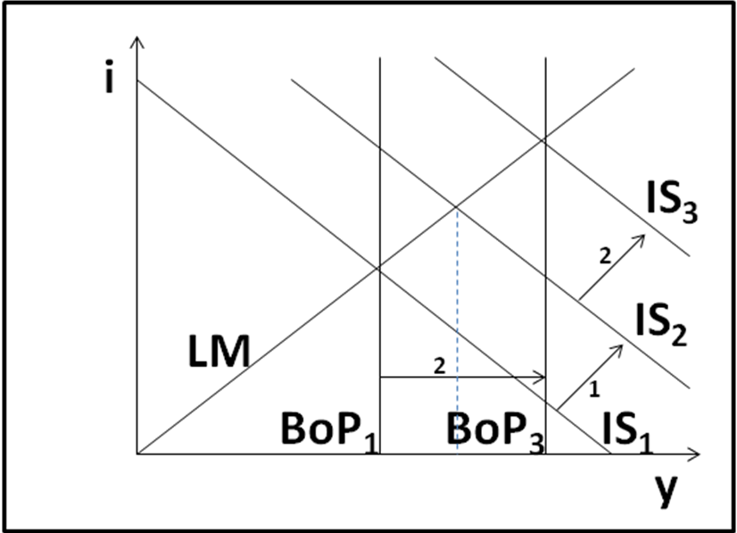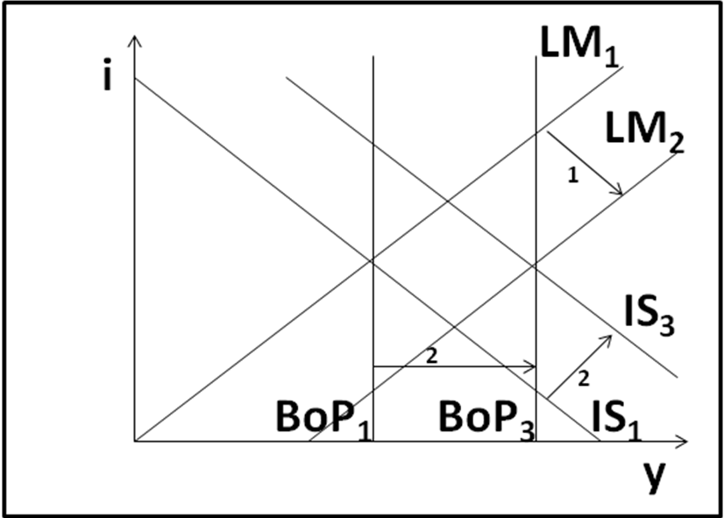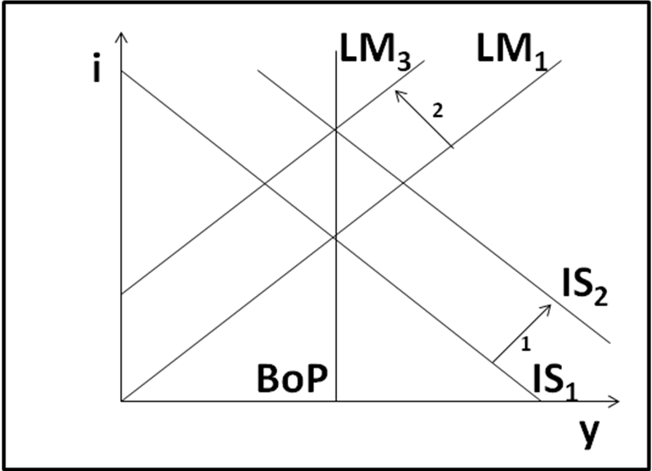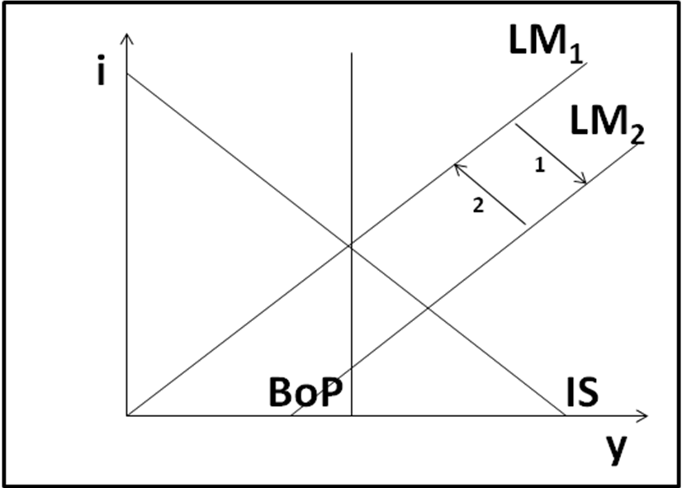
MF: no CM, float, fiscal MF: no CM, float, monetary MF: no CM, fixed, fiscal MF: no CM, fixed, monetary

